ASSIGNMENT SUBMISSION COVER SHEET
Student Id:
cse25-262
Student names:
Boitshwaro Leago Motlhose
Student email:
cse25-262@thuto.bac.ac.bw
Cohort:
Group 1-1
Assignment title:
SCIS WMD_2026 AO1
Date of submission:

Programme of Study:
COMPUTER SYSTEMS ENGINEERING
Year of Study:
Year 1
Intellectual property statement By checking the box below, I certify that this assignment is my own work and is free from plagiarism. I understand that the assignment may be checked for plagiarism by electronic or other means and may be transferred and stored in a database for the purposes of data-matching to help detect plagiarism. The assignment has not previously been submitted for assessment in any other unit or to any other institution. I have read and understood the Botswana Accountancy College plagiarism guidelines policy.
☐ Agree
Signature……………………………………. Date………………………………………….

OCULENS EYEWEAR

WEBSITE SPECIFICATIONS

WEBSITE OBJECTIVE: The objective of Oculens Eyewear website is to provide users with an accessible and informative platform to explore a wide range of eyewear products and professional eye care services. The website aims to promote the brand, showcase services that are provided, and allow buyers to contact and physical get to the business. The site is designed to deliver a user friendly interface and be responsive to all devices and web browsers.

WEBSITE GOALS

- Promote the brand – To increase awareness of Oculens Eyewear and establish a strong online presence.
- Display products and services -To showcase the eyewear, services such as eye testing available to customers in an informative way.
- Improve customer engagement -To allow users to easily navigate through the website, learn more about the services being provided, and interact through the contact page.
- Provide necessary information -To give customers access to essential details of the business, especially the services and the products available.
- Ensure a user friendly experience -Which allows easy access to the users, devices and browsers.

TARGET AUDIENCE

The target audience of Oculens Eyewear website includes all age groups; toddlers, teenagers, young adults, adults and the elderly who require vision correction or are interested in fashionable eyewear. The primary audience is people living in and around Gaborone, but it is also available for remote potential customers. The website also targets working people as well as students, with a middle-income level and students’ discounts allowing them to afford eye care services and products provided.
Age group: 1-80 years
Gender: Male and Female
Demographics: Students and working adults
Location: Botswana

TECHNICAL APTITUDE

- Site is fast and easily accessible by all web browsers
- Site is responsive and adaptive even for small screens
- Site has interactive tools such as visual try on which uses Augmented Reality (AR)
- Site runs the cart and check-out smoothly and securely

TYPE OF WEBSITE

Oculens Eyewear website is an ELECTRONIC COMMERCIAL ( e-commerce ) website that allows customers to browse, select and purchase eyewear products online. In addition to selling products, the website also provides essential information about eye care services such as eye testing, frame fitting , etc. It is designed to offer a convenient, user-friendly, and secure shopping experience, allowing customers to interact with the business anytime and anywhere.

INFORMATION DESIGN & TAXONOMY

INFORMATION ARCHITECTURE

SITE STRUCTURE

- HOME
- Hero banner (displays featured products/ promotions
- Quick links (services, about, shop and contact information)
- Featured categories (Women’s, Men’s eyewear, Kids glasses, Sunglasses, contact lenses and accessories)
- Best sellers
- New arrivals

- ABOUT
- Company overview
- Mission and Vision
- Why choose Oculens

- SERVICES
- Bookings for eye test
- Vision screening information
- Eye health tips

- SHOP
- Spectacles (Women, Men, Kids, Blue Light and Prescription glasses)
- Sunglasses (All ages, fashion/Designer brands)
- Accessories (Cases, cleaning kits and lens solutions)
- Contact lenses (Daily, monthly and coloured lenses)
- Prices, Frame material, frame shapes and brand

- CONTACT
- Contact form
- Phone/Email
- Store location
- Social media links

The website is designed into the above sections to make it easy for users to navigate and find products they desire without any hassle and quickly. The labelling also improves user comprehension while ensuring smooth transitions across all links, moreover it helps customers to make efficient transactions.

SITE NAVIGATION STRUCTURE

SITE MAP

Home
│
├── Shop
│ ├── Eyeglasses
│ │ ├── Men
│ │ ├── Women
│ │ └── Kids
│ │
│ ├── Sunglasses
│ │ ├── Men
│ │ └── Women
│ │
│ ├── Contact Lenses
│ │ ├── Daily
│ │ └── Monthly
│ │
│ └── Accessories
│
├── Eye Care Services
│ ├── Book Eye Test
│ ├── Lens Guide
│ └── Eye Health Tips
│
├── About Us
│ ├── Our Story
│ └── Mission & Vision
│
├── Support
│ ├── FAQs
│ ├── Shipping & Delivery
│ └── Returns & Refunds
│
├── Contact Us
│
├── Account
│ ├── Login / Register
│ ├── Profile
│ └── Order History
│
└── Cart / Checkout

PAGE TEMPLATE DESIGN

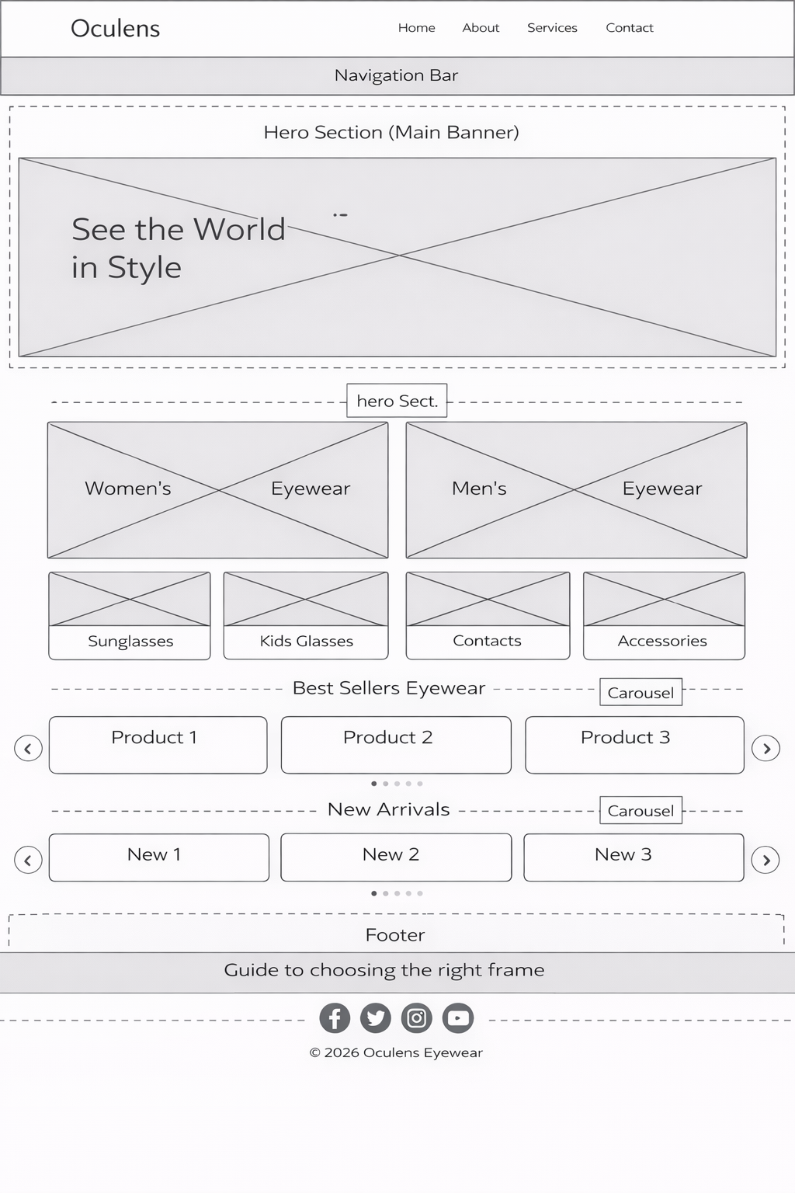

TECHNICAL BRIEF

Oculens will use different web technologies to ensure that it is user-friendly and is accessible by all web browsers and all devices.

HTML5- Which will be used to create the structure of the website making it easy for users to navigate through it easily.
CSS3- This will be used to control the layout, colours and styling, therefore making the website appealing to the eyes of the user.
Bootstrap- It will be used to help with responsive design so that users can interact with the website resulting in both parties receiving feedback regarding the intermediate goal (products).
Javascript- Will be used for navigation interactions and dynamic content.
Web browsers (Safari, Google Chrome, Microsoft Edge)- Will be used to check accessibility of the website.
Visual Studio Code- Will be used to write the code behind the website, detect any errors and suggest how to correct them.

